The purpose of the experiment “Find a procedure to transfer files from one virtual machine (VM) to another VM” is to understand how systems communicate and exchange data over a network.
Below is the explanation in Theory, Practical, and Real-time use.

1. Theory (Concept)
Virtual machines created using software like VirtualBox or VMware Workstation behave like independent computers on a network.
File transfer between VMs is done using network communication protocols.
Common protocols used:
- Secure Copy Protocol (SCP) – secure file transfer over SSH
- File Transfer Protocol (FTP) – classic file transfer protocol
- Secure Shell (SSH) – remote login and secure communication
- Server Message Block (SMB) – file sharing used by Windows networks
- Hypertext Transfer Protocol (HTTP) – file download via web server
For communication:
- Both VMs must be connected to the same virtual network.
- Each VM must have a unique IP address.
- The sender uses the receiver’s IP address to transfer the file.
This experiment demonstrates network communication, IP addressing, and file transfer protocols.

3. Real-Time Applications
This concept is widely used in real environments:

1. Server administration
System administrators transfer configuration files between servers using Secure Copy Protocol.

2. Cloud computing
Files are uploaded from local machines to cloud servers like Amazon Web Services or Google Cloud.

3. Software development
Developers transfer code from their local machine to testing servers.

4. Cybersecurity labs
Security professionals transfer tools and logs between attack and target machines.

5. Backup and data migration
Organizations move data between servers or virtual machines for backup and recovery.

4. Conclusion
This experiment helps students learn:
- Virtual networking
- IP addressing
- Network connectivity
- File transfer protocols
- Practical system administration skills
It also demonstrates how real computer networks exchange data securely between systems.

1️⃣ Similar Concept (File/Data Transfer)
Apps like WhatsApp also transfer data between devices using the internet and IP networks.
When you send a message, photo, or video:
- Your phone connects to the internet.
- The message is sent to WhatsApp servers owned by Meta Platforms.
- The server forwards the message to the receiver’s phone.
So the basic process is:
Sender → Server → Receiver
This is similar to transferring files between computers, but with servers in the middle.

2️⃣ How It Differs From Your VM Experiment
VM File Transfer | WhatsApp Messaging
Direct computer-to-computer | Goes through WhatsApp servers
Uses commands like scp | Uses mobile app interface
Usually inside a local network | Works worldwide through the internet
Simple protocols | Advanced encrypted communication

3️⃣ Security (Very Important)
WhatsApp uses Signal Protocol for end-to-end encryption.
This means:
- Only the sender and receiver can read the message.
- Even WhatsApp servers cannot see the content.
So the process becomes:
Phone A (encrypt message)
↓
WhatsApp Server (cannot read it)
↓
Phone B (decrypt message)

4️⃣ Real-Life Comparison
Your VM experiment:
VM1 ───────► VM2
WhatsApp system:
Phone A ─► WhatsApp Server ─► Phone B
Both involve:
- Network communication
- IP addresses
- Data transfer

✅ Conclusion:
Yes, the basic networking concept is the same (sending data from one device to another), but WhatsApp adds servers, encryption, and global internet infrastructure.

VirtualBox File Transfer Between Two VMs (M1 & M2)

Step 1: Create Two Virtual Machines

VM1 (M1):
- Open VirtualBox → Click New.
- Name: M1
- Type: Linux
- Version: Linux Mint (64-bit)
- Memory: 2048 MB (2 GB) or more
- Hard disk: Create a virtual hard disk → VDI → Dynamically allocated → 20 GB
- Click Create.

VM2 (M2):
- Repeat the same steps as M1.
- Name: M2
- Same type, version, memory, and disk.
- Click Create.
✅ You should now see both VMs: M1 and M2.

Step 2: Configure Network Adapters (Wi-Fi)

VM1 (M1):
- Select M1 → Settings → Network
- Adapter 1:
  - Enable Network Adapter ✅
  - Attached to: Bridged Adapter
  - Name: Select your Wi-Fi adapter (e.g., Intel Wireless)
  - Promiscuous Mode: Deny
  - Cable Connected: ✅
- Adapter 2 (optional):
  - Enable Network Adapter ✅
  - Attached to: Host-Only Adapter (default vboxnet0)
  - Promiscuous Mode: Deny
  - Cable Connected: ✅

VM2 (M2):+
- Repeat the exact same steps as M1.
- Ensure both VMs use the same Wi-Fi adapter for Bridged Adapter.

Test Network:
- Start VM1 → Terminal:
ip a

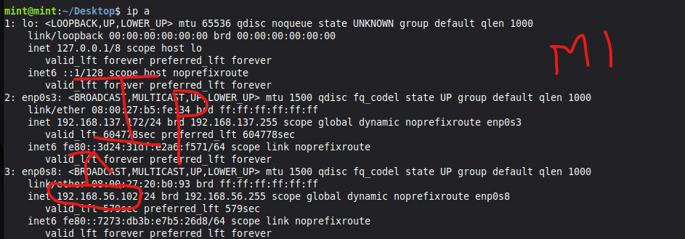

- Start VM2 → Terminal:
ip a

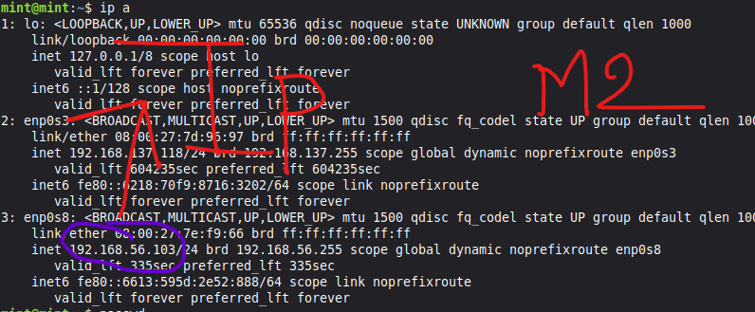

- Ping from M1 to M2:
ping 192.168.56.103

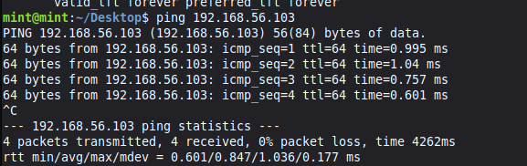
✅ Successful ping means network is working.

Step 3: Transfer Files Between VMs

Step 3a: Install SSH on Destination VM (M2)

sudo apt update

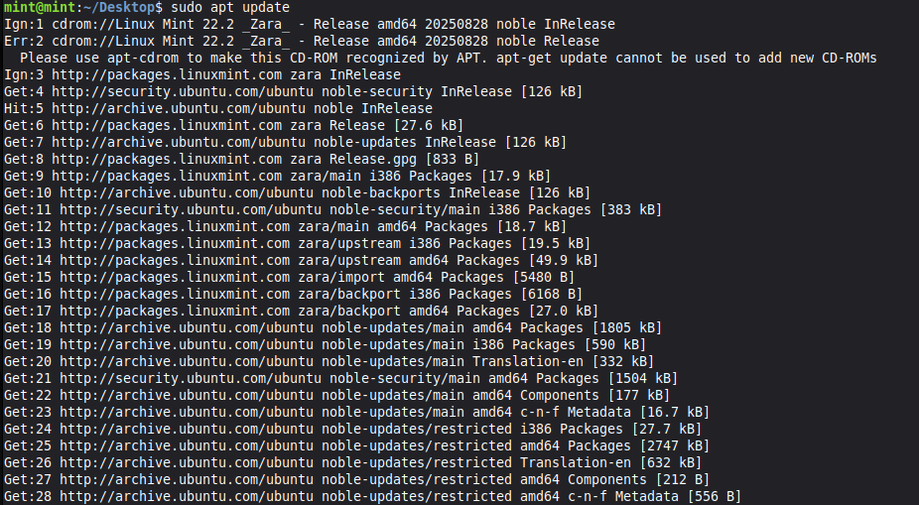

sudo apt install openssh-server

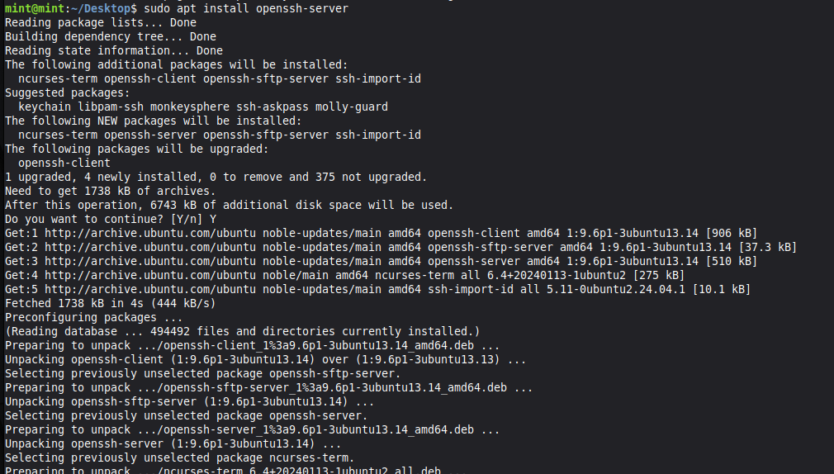

sudo systemctl start ssh
sudo systemctl status ssh

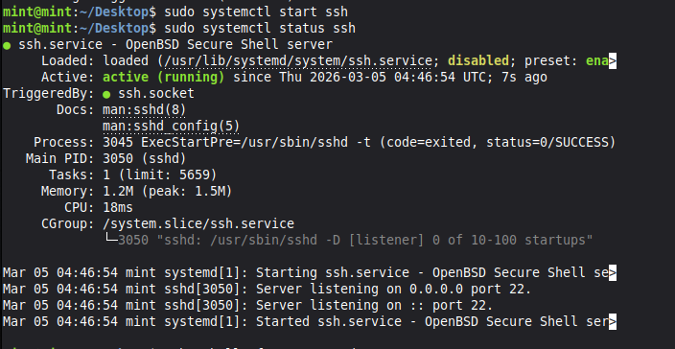
- Make sure SSH service is active (running).

Create a file

Step 3b:Set password for m2
Open m2:
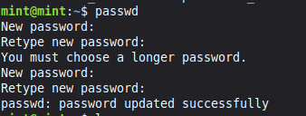

Step 3c: Transfer file from M1 to M2
On M1, run:
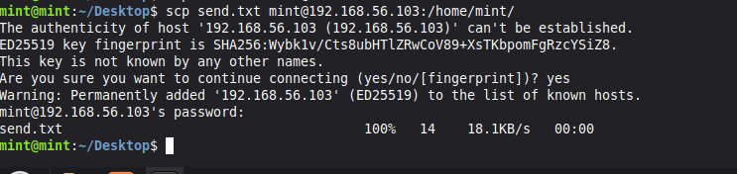
- Replace /path/to/file.txt with the file path.
- Replace user with M2’s username.
- Enter M2 password when prompted.

Step 3d: Verify the file on M2

